- Reference:

Mucous Extractor 25 & 40ml.

- Definition:
A mucous extractor is a device which is indicated for use in new-born, infants or small children to clear their nasal passage or for suctioning tracheal/bronchial secretion samples of neonates, children and adults for the purpose of laboratory analysis.
- Scope:
This document describes the specifications of Mucous Extractor for single use delivered STERILE by Saudi Mais Co. for Medical Products.

- Quality Points:
- Transparent & Strong container for clear observation.
- Soft Suction tube with two lateral eyes & open tips
- Connector funnel & with finger control.
- Tube length 45-50cm.
- With anti-reflux valve.
- Made of PVC, PC, PE material.

- Product Code Number:

  - Mucous Extractor 25ml (Funnel Control Type Connector):

SR. No. | Product Code | Description
 | 371-0550 | Mucous Extractor with NRV Size CH 05 - Funnel Control Sterile
 | 371-0650 | Mucous Extractor with NRV Size CH 06 - Funnel Control Sterile
 | 371-0850 | Mucous Extractor with NRV Size CH 08 - Funnel Control Sterile
 | 371-1050 | Mucous Extractor with NRV Size CH 10 - Funnel Control Sterile
 | 371-1250 | Mucous Extractor with NRV Size CH 12 - Funnel Control Sterile
 | 371-1450 | Mucous Extractor with NRV Size CH 14 - Funnel Control Sterile
 | 371-1650 | Mucous Extractor with NRV Size CH 16 - Funnel Control Sterile

  - Mucous Extractor 25ml (Finger Control Type Connector):

SR. No. | Product Code | Description
 | 370-0550 | Mucous Extractor with NRV Size CH 05 - Finger Control Sterile
 | 370-0650 | Mucous Extractor with NRV Size: CH 06 - Finger Control Sterile
 | 370-0850 | Mucous Extractor with NRV Size: CH 08 - Finger Control Sterile
 | 370-1050 | Mucous Extractor with NRV Size: CH 10 - Finger Control Sterile
 | 370-1250 | Mucous Extractor with NRV Size: CH 12 - Finger Control Sterile
 | 370-1450 | Mucous Extractor with NRV Size: CH 14 - Finger Control Sterile
 | 370-1650 | Mucous Extractor with NRV Size: CH 16 - Finger Control Sterile
 | 370-1600 | Mucous Extractor with NRV Size: CH 16 - with single chamber Sterile

  - Mucous Extractor 40ml:

SR. No. | Product Code | Description
 | 372-1050 | Mucus Extractor Pediatric Size CH 10 - Funnel Control Sterile
 | 372-0850 | Mucus Extractor Pediatric Size CH 08 - Funnel Control Sterile.
 | 372-40ML | Mucus Extractor Specimen Plastic- For Collection 40ML
 | 372-80ML | Mucus Extractor Specimen Plastic- For Collection 80ML

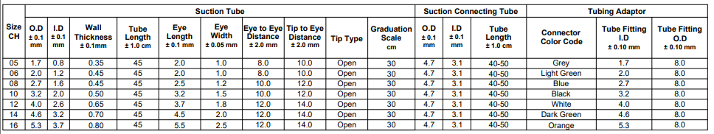
- Product Specification Table for Suction Tube:

- Product Drawings & Dimensions:
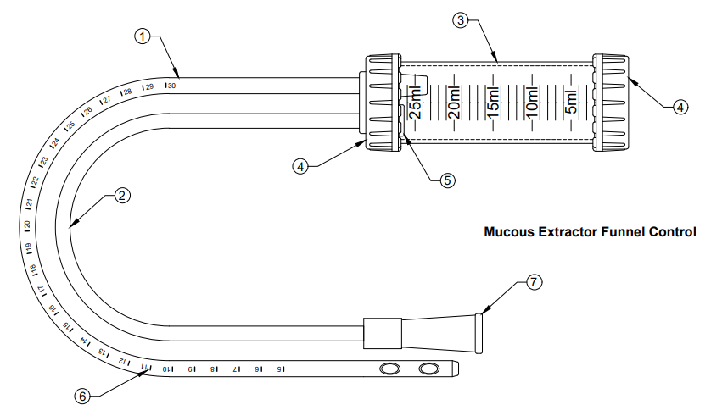
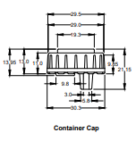
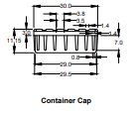
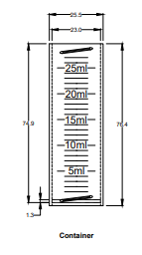
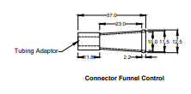
  - Mucous Extractor 25ml

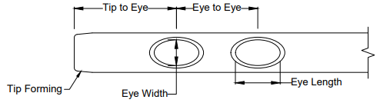

    - Material Specification of Mucous Extractor Funnel Control Connector:
Parts Name | Parts Descriptions | Materials
 | Suction Tube | PVC
 | Suction Connecting Tube | PVC
 | Container | PC
 | Container Cap | PE
 | NRV | PE + Filter
 | Graduation Scale | Black Ink
 | Funnel Control Connector | PVC

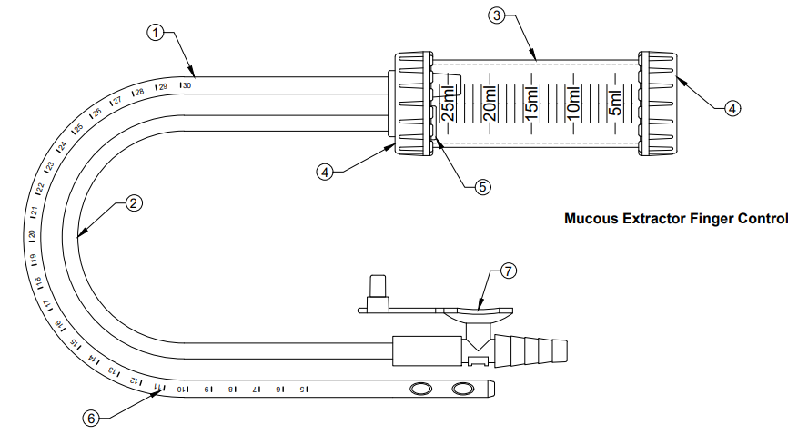
  - Mucous Extractor 25ml Finger Control Connector:

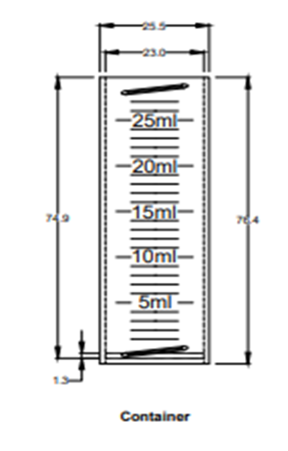
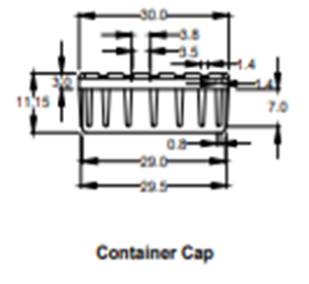
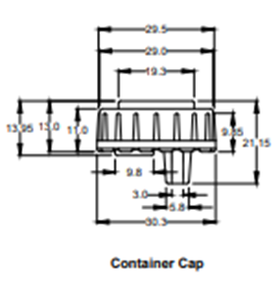

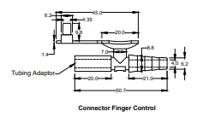

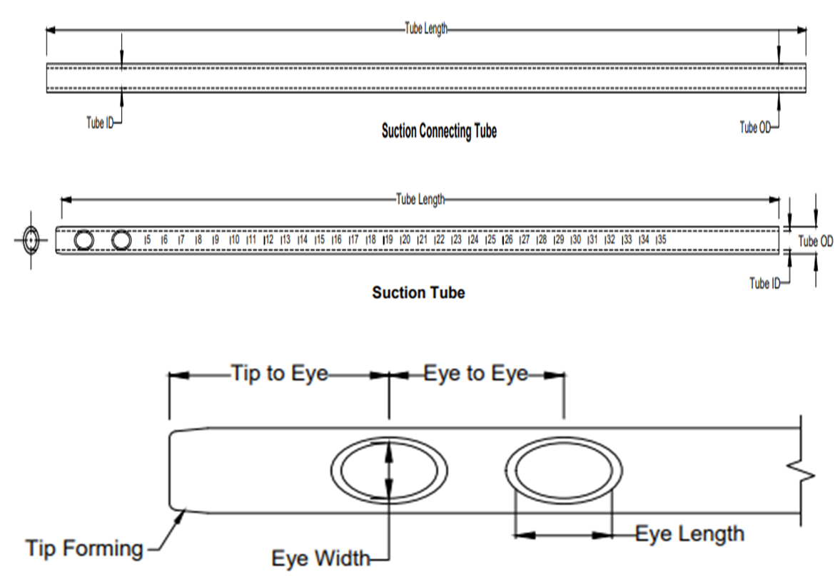

    - Material Specification of Mucous Extractor 25ml Finger Control Connector:
Parts Name | Parts Descriptions | Materials
 | Suction Tube | PVC
 | Suction Connecting Tube | PVC
 | Container | PC
 | Container Cap | PE
 | NRV | PE + Filter
 | Graduation Scale | Black Ink
 | Finger Control Connector | PVC

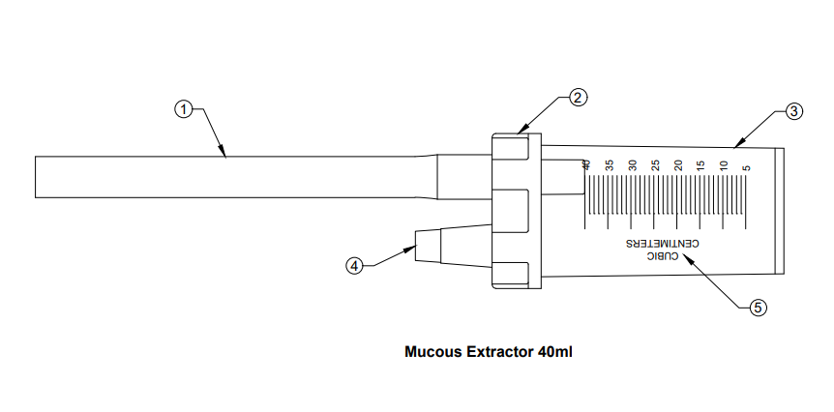
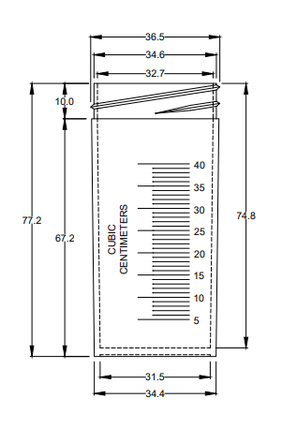
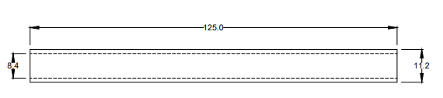
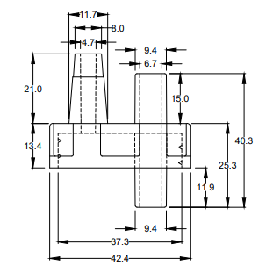
  - Mucous Extractor 40ml:

    - Material Specification of Mucous Extractor 40ml:
Parts Name | Parts Descriptions | Materials
 | Suction Connecting Tube | PVC
 | Container Cap | PE
 | Container | PC
 | Suction Connecting Port | PE
 | Graduation Scale | Blue Ink

Product Attributes
Sr. No. | Parts
 | Suction Tube: Suction tubes illustrated are designed for removing small amounts of secretions from the nose, throat or ears & chest.
 | Graduation Scale: Graduation scale make by PVC black ink. The function of graduation scale help to measure tube for insertion on patient body.
Suction Connecting Tube: Suction connecting tube made of PVC material. The function
of use for suction connecting tube adjusted with vacuum machine or syringes for sucking the mucus from patient body.
 | Funnel Type Connector: Funnel type connector made of PVC material. The function of use for connecting to the catheter tip syringe or vacuum machine.
 | Finger Control Type Connector: Finger control type connector made of PVC material. The function of use for connecting to the vacuum machine.
 | Container: The container made of PC material. The function of use for store the patient mucus.
 | Container Cap: The container cap made of Pe material. The function of use for closed the container.
 | Suction tube connecting port: The suction tube connecting port made by PE material. The function of use for connected the suction tube (funnel type) connector.

- Physical Properties:
  - Visual appearance:
Clear / Good Appearance. No damaged, No Short Shot, No flashing.

  - Suction Tube status:
Good appearance. Clear & transparent. Open tip with two lateral eyes. Free from irregularities.
  - Suction tube connector:
Clear appearance, good status no flushing, No short shot. good fitting with suction tube. No leakage.

  - Container w/cap:
Clear & transparent. no flashing, no crack & no edge broken. Cap good/tight fitting with
container. The tube also good fitting with cap, no leakage & no pullout.

  - NRV (Non-Return Valve) status:
NRV has good appearance. Good fitting on inside the cap. NRV proper working.

  - Dimension status:
Dimensions are accurate are in accordance with specification table.
  - Tube fitting into connector:
The tube into parts fitting is in accordance with standard 8836:2019.

  - Leakage and Flow test
The tube leakage and flow rate test as per standard 8836:2019 Annex D.
- Biological properties:
After sterilization by ethylene oxide, the product fulfils the requirements of EN ISO 10993 for: Cytotoxicity,
Irritation,
Sensitization.
- Sterility:
Routine release for sterility is based on the control of physical parameters and a sterility control on biological indicators in accordance with EN 11135-1.
- Product Carton & Box specifications as per (F42-S10):

SR. No. | Product Descriptions | 34x23x16.5cm |  | 51x35x36cm
SR. No. | Product Descriptions | Pcs/Box | Small Box | Pcs/Carton
SR. No. | Product Descriptions | Qty. | Qty. | Qty.
 | Mucous Extractor (25ml) | 50 | 4 | 200
 | Mucous Extractor (40ml) | 20 | 4 | 80

- Packaging and labelling:
Each Mucous Extractor 25 & 40ml is packed in a blister pack to guarantee the sterility of the inside when perforations are not broken.
The single piece label contains the following information:
- The item name and code / reference.
- For single use, ETO sterilized, read instruction, store temperature.
- Lot number and expiry date, production date.
- If latex contain or latex free.
- CE marking 1639.
- Manufacturer name and address.
- Authorized European Representative Name and address.

The label on the shipping big carton bears at least the following information:
- Item name and code / reference.
- Lot number.
- Sterilization date.
- For single use, ETO sterilized, read instruction, store temperature.
- CE marking 1639.
- Manufacturer name and address.
- Authorized European Representative Name and address.
- Quantity per carton.
-And the cartons contain the fallowing symbol; keep side up – upside down prohibited.
- Do not expose to direct sunlight, store at room temperature.
- Handle with care.
- Use no hooks.
- Fragile.
- Do not stock more than 8 cartons.
- Expiry:
The expiry date is (05) years from its Production date.

- Documents Changing History:
Date | Changing History | Revision No.
22.09.2014 | Added Doc. History table | 06
06.02.2023 | Added technical drawings | 07

Prepared By:  Q.A. Coordinator: | Checked By:  Q.C.M: | Approved By:  Q.A.M:

